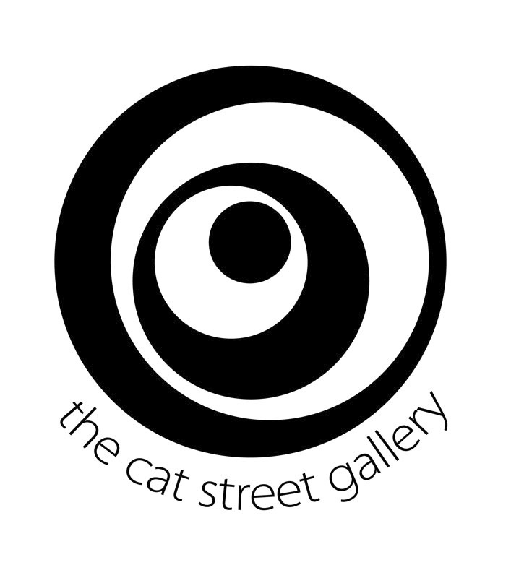

Emma Hack
CURRICILUM VITAE

Education

1990 Completed Makeup Artisty and Technology, Peacock Academy
1995 Shermans Academy of Hairdressing
Self taught Artist, ‘School of Life’

Individual exhibitions

2016 Savina Museum of Contemporary Art - Solo Exhibition ‘Body Flower’
Singapore Contemporary, Emma Hack Gallery, Singapore
2014 – 2016 Various Exhibitions, Emma Hack Gallery, North Adelaide, SA
2015 ARTJakarta, The Cat Street Gallery, Jakarta
Gallery One, Gold Coast , QLD
2014 Eden, Adelaide, Town Hall, King William St, Adelaide, SA
Rebecca Hossack Gallery, London, UK
Linton and Kay Galleries, Perth, WA
Rebecca Hossack Gallery, NYC, USA
Seaview Gallery, Queenscliff, VIC
2013 Florence Wallpapers, Signature Prints, Sydney, NSW
Bluerider Art, Taipei, Taiwan
The Cat Street Gallery, Hong Kong
Catherine Asquith Gallery, Beautiful Women, Melbourne, VIC
Frances Keevil Gallery, Double Bay, NSW
Catherine Asquith Gallery - Treasured Tiles, Melbourne, Australia
Retrospect Galleries,Byron Bay, NSW
Seaview Gallery - Queenscliff. VIC
2012 Elements Art Gallery, Perth, WA
AP BOND – SALA – Magill, SA
Henley Festival (UK) - Rebecca Hossack Gallery, UK
ART Melbourne, Stand C8, Melbourne, VIC
Frances Keevil Gallery – Sydney, NSW
Catherine Asquith Gallery, Melbourne VIC
2002-2012 - 10 year retrospective, Adelaide Convention Centre, SA
Seaview Gallery, Queenscliff Gallery, VIC
2011 AP Bond, Stepney SA
Lethbridge Gallery, Brisbane, QLD
Affordable Art Fair, (represented by Rebecca Hossack Gallery), NYC, USA
AP Bond, Stepney, SA
Frances Keevil Gallery, Double Bay, NSW
Seaview Gallery, Queenscliff, VIC
ART Melbourne, Royal Exhibition Buildings, Carlton, VIC
London Art Fair (represented by Rebecca Hossack Gallery), London, UK
2010 Gallery 139, Magill, SA
Obscura Gallery, East St Kilda, VIC
ART Sydney, represented by Frances Keevil Gallery, NSW
Elements Art Gallery, Dalkeith, WA
Cessnock Regional Gallery, NSW
Art Melbourne 10, Royal Exhibition Buildings, Carlton, VIC
ART Melbourne, Royal Exhibition Buildings, Carlton, VIC
Frances Keevil Gallery, Sydney, NSW
Manyung Gallery, Mt Eliza, VIC
2009 Gallery 139, Magill, SA
Art Sydney 09, Royal Hall of Industries, Sydney, NSW
Frances Keevil Gallery, Sydney, NSW
Obscura Gallery, Melbourne, VIC
Art Melbourne 09, Royal Exhibition Buildings, Carlton, VIC
Adelaide Airport, SA
2008 Art Images Gallery, Adelaide, SA
Art Sydney 08, Royal Hall of Industries, Sydney, NSW
Melrose Gallery, Melrose, SA
2003 – 2007 The Arthouse Hotel, Sydney, NSW
2004 Adelaide Cabaret Festival, Adelaide Festival Centre, Adelaide, SA
2003 FAD Gallery, Adelaide, SA

Selected group exhibitions

2015 The art Of Illusion, Rebecca Hossack Gallery, NYC
SNAP! Crocodile Culture, Rockhampton Art Gallery, QLD
2014 Melbourne Art Fair 13th-17th August, Cube Contemporary Art Projects, VIC
‘The Act of Seeing’, Town Hall Gallery. Hawthorn, VIC
The Cat Street Gallery ANNEX, Hong Kong
2012 – 2014 Retrospect Gallery (ART Fairs) Singapore, Hamburg, Mexico,
Amsterdam, Toronto, NYC, Stockholm, Hong Kong, Singapore, Brussels,
Milan
2013 Taipei Art Photo Show, with Bluerider Art Gallery, Taiwan
Rebecca Hossack Gallery, (ART Fairs) NYC, ART Aspen, ART Hampton,
Singapore
2012 Frances Keevil Gallery – Group Christmas Show, Sydney, NSW
Catherine Asquith Gallery – Group Christmas Show, Melbourne, VIC
Rebecca Hossack – NYC, USA
Vue Privee – Singapore
2011 Festivité 2011, Catherine Asquith Gallery, Melbourne, VIC
Group Show, Frances Keevil Gallery, Sydney, NSW
Seaview Gallery, Queenscliff, VIC
19 Karen, Gold Coast, QLD
Elements Gallery, Dalkeith, WA
2010 World Body Painting Festival, Austria
Manyung Gallery, Mt Eliza, Vic
Frances Keevil Gallery, Sydney, NSW
2009 Manyung Gallery, Mt Eliza, Vic
Francis Keevil Gallery, Sydney, NSW
2008 Retrospective Works, Brunswick St Gallery, Melbourne, Vic
Art Moments Gallery, Sydney, NSW
Marie Hart Galleries, Adelaide, SA
2004 Greenhill Galleries, Adelaide, SA
2002 Greenhill Galleries, Adelaide, SA

Awards

2016 Finalist: Scope Galleries - Art Concerning Environment Award - 'Highly
Commended'
2012 Australian Design Biennial – Wallpaper Collection 2005-2010; Artist Book
2011 One Show Design (USA) – Merit - Wallpaper Collection 2005-2010; Artist
Book
Communication arts( USA) – Award of Excellence - Wallpaper Collection
2005-2010; Artist Book
ARIA - Award for best Video – Somebody That I Used To Know
2008 Emerging Artist Award, Affordable Art Fair, Sydney
2001 World Body Painting Champion, CIDESCO, Hong Kong

Public Collections

The M Collection, Melbourne, Vic
National Portrait Gallery, Canberra, ACT
Adelaide Festival Centre, Adelaide, SA
Private collections throughout Australia, Europe, UK, USA, Taipei, Hong Kong, Canada and Singapore

